**CAUSAL THEORY**

**Definition:**

Causality governs the relationship between events. The world consists of a collection of causal systems; in each causal system there is a set of observable causal variables. Note that correlation doesn’t imply causality.

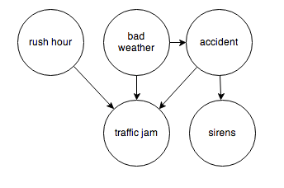

## What is Causation?

Causation is implying that A and B have a cause-and-effect relationship with one another.

**What is Correlation?**

Correlation is a term in statistics that refers to the degree of association between two random variables. So the correlation between two data sets is the amount to which they resemble one another.

**Difference between correlation and causation:**

Example: Suppose mobile phone freezes when we try texting, these events are related but texting is not causing the phone to freeze it maybe because there might be other apps open at the same time which are utilizing ram and when we try to text the phone freezes. The act of trying to send a text message wasn’t causing the freeze, the lack of RAM was.

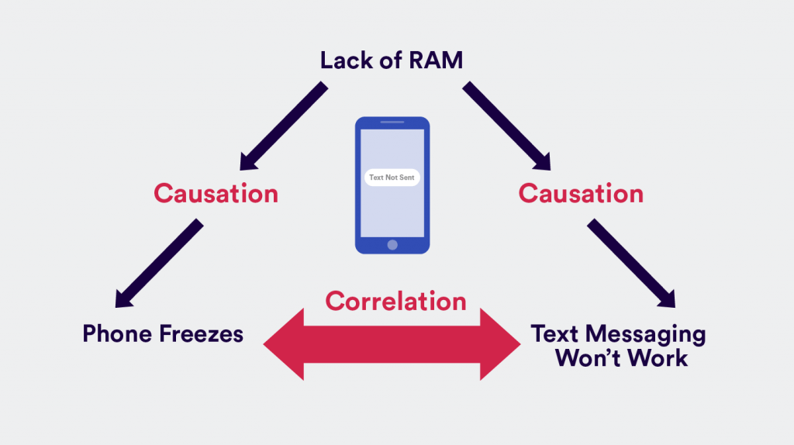

**Causal Inference:**

The causal inference is the prediction of the outcome of an intervention. For example, a treatment assigned by a doctor that will change the patient’s heart condition is an intervention. Predicting the change in patient condition is a causal inference task.

In general, an intervention is an action taken by an external agent that changes the original values, or the probability distributions, of some of the variables in the system.

**Structure of Causal Inference:**

A common way for expressing the relationship between the different states of the world is a causal graph. A causal model is composed of the graph and a probability distribution that factorizes according to the graph.

Directed acyclic graphs (DAGs) are used to represent causal relationships. A DAG is composed of a set of vertices and a set of directed edges.

In terms of causal statements, a directed edge A → B states that A is a direct cause of B: that is, different interventions on A will result on different distributions for B, even if we intervene on all other variables.

A causal DAG G satisfies the causal Markov condition if and only if a vertex is independent of all of its non-descendants given its direct causes (parents). A is independent of D, E and F given its parents, B and C. It may or may not be independent of G given B and C.

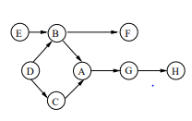

**Intervention:**

Causal effects of variables can be manipulated.

The role of an intervention is to override the natural local mechanism. An external agent substitutes the natural distribution by a new distribution while keeping the rest of the model unchanged

